Jason & EJ,
Here are some thoughts/questions about the effect of preservation on Mysid length.

- I removed the juveniles from the analysis as they were removed from the L-W analysis (they were removed from the L-W analysis because we did not have confidence in the weight measurements that we were getting for such small individuals). In addition, there are some (minor?) issues with the juvenile data – much wider length range for the 8SBF treatment and some surprisingly large length losses for the very small individuals (I suppose we could re-measure these to confirm). [Note: the loss.p2w variable is the loss in length after two weeks of preservation and len.fr is fresh length.]
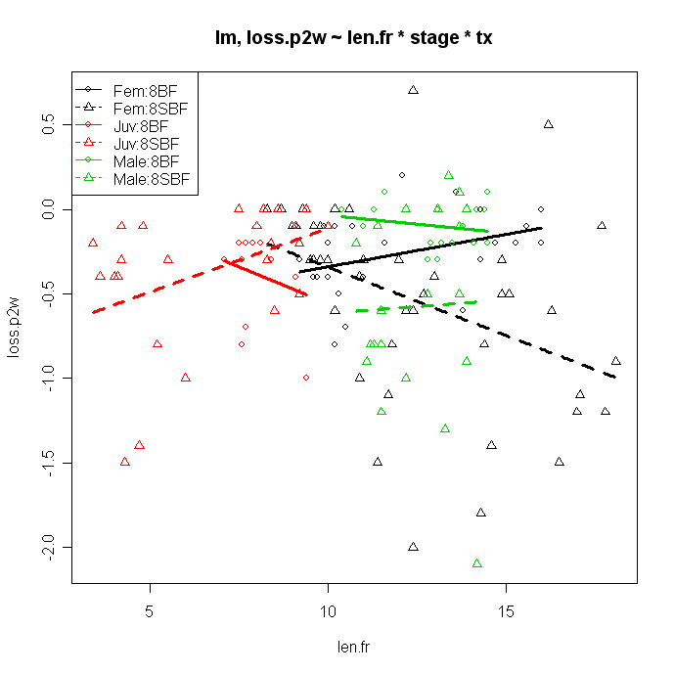
- When the juveniles are removed there is a significant len.fr:tx interaction indicating that the slope of loss.p2w on len.fr differs between the 8BF and 8SBF treatments. However, I think that most of this slope effect is due to the 8SBF:Female group because (a) this group has a larger sample size and (b) it has a wider range of length values (note width of black-dotted line below versus red-dotted line). I then did a one-way ANCOVA on the data and found that the 8SBF:Female group did have a weakly significantly different slope from the other groups (p~0.06).
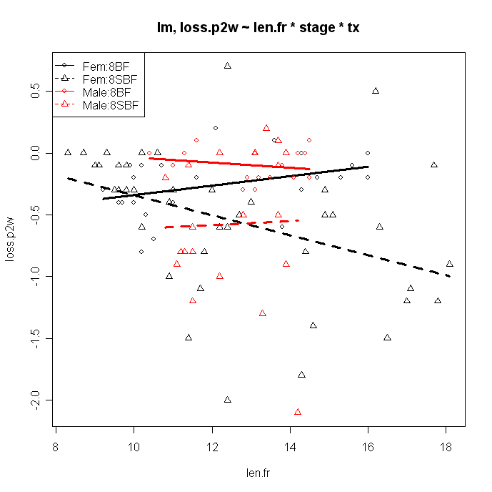
- I then noticed that the 8SBF:Female likely had a negative slope because of the few individuals at small lengths that exhibited no loss of length. I then limited the data to only those individuals larger than 10 mm (thus removing those individuals, plus a few others) and found that the slopes of all groups were now statistically similar.
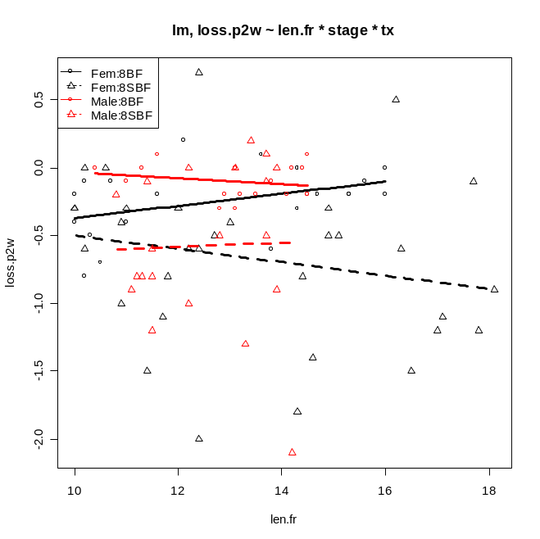

So, the question is how should we proceed. Do we want to remove the juveniles or just analyze them separately? For the males and females do we want to include all data or limit it to those greater than 10 mm. If we want the latter then we could argue that the different slope for the 8SBF:Female group was largely the results of a paucity of data from 9.5-10 mm and not a “real” difference. However, this smells of “data-sniffing.” The interpretation with the restriction of those greater than 10 mm is much simpler – i.e., there is no effect of length on loss of length, the 8BF treatment loses a constant amount (I haven’t tested if this is significantly different from zero yet) and the 8SBF group loses a constant amount and that amount is larger the loss in the 8BF group (I have not tested this yet either).

Another interesting observation is to note that the variability in the loss of length is much larger for the 8SBF group then the 8BF group.

Anyways, if you have time for some thoughts before meeting on Thursday then let me know. If we can decide on a way to go then I can include that analysis and text into the document.

